Peruvian Park Elementary
Empowering students to build their own success.
Character, Confidence, Academics
Managing Student Behaviors

Students can manage their own behavior when:

- Adults form positive relationships with students.

- Instruction is engaging.

- Expectations are consistent within classroom and school.

- All adults in building are committed to success of all students.

- All adults teach and reteach expected behaviors.

- All adults in the building model expected behaviors.

Peruvian Park Elementary will implement a comprehensive school management plan including PBIS, teaching interactions, and appropriate consequences.

PBIS
Teaching behavioral expectations and rewarding students for following them is a much more positive approach than waiting for misbehavior to occur before responding.
The purpose of school-wide PBIS is to establish a climate in which appropriate behavior is the norm and expectations are clear, consistent and valued throughout the school.
School-wide systems of support that include proactive strategies for defining, teaching, and supporting appropriate student behaviors create positive school environments.

All classes will participate in school wide PBIS plan based on expectations of Safety, Respect and Responsibility.

- Define school wide expectations for specific areas of building
- Create and implement lesson plans to teach expectations consistently at all grade levels.
- Determine and use positive behavioral support system
- Conduct program to review expectations
- Track and analyze data for positive supports, ODR. Modify plan based on assessed needs.
- Build in review, maintenance, and reinforcement of expectations throughout the year.
 | BE SAFE | BE RESPECTFUL | BE RESPONSIBLE
ARRIVAL AND  DISMISSAL | *Use sidewalks & crosswalks safely.  *Leave/enter car onto sidewalk from passenger side only.  *Line up by your grade level doors for the bell. | *Use kind, appropriate words.  *Follow Safety Patrol and adult directions. | *Arrive and line up on time by 8:15.  *Go directly home at 2:55.  *Walk bikes and scooters on school grounds.
HALLS | *Walk to the right facing forward.  *Keep hands, feet and objects to yourself. | *Quiet Zone  *Wait patiently for your turn.  *Walk softly on ramps and stairs.  *Follow adult directions. | *Take proper care of personal belongings and school property.  *Keep up with class and stay in line.  *Let visitors pass.
CAFETERIA | *Wash or sanitize hands.  *Sit at your grade table.  *Walk at all times.  *Eat only your own food.  *Remain seated until dismissed. | *Be courteous.  *Use good manners and  a quiet voice.  *Follow adult directions. | *Clean up after yourself.  *Keep food inside.  *Go straight outside after eating.  *Use the cafeteria restroom on the way out to recess.
PLAYGROUND | *Stay inside the fence and in sight of an adult.  *Use equipment properly.  *Keep snow on the ground. | *Be fair and courteous.  *Use kind language.  *Include everyone.  *Follow adult directions the first time given. | *Be aware of activities around you.  *Dress properly for outside recess.  *One at a time on equipment.
BATHROOMS | *Keep water in sink.  *Keep feet on the floor.  *Always wash hands with soap and water. | *Quiet Zone  *Knock on the stall door if the door isn’t open.  *Respect others’ privacy.  *Leave the light on. | *Flush toilet.  *Put paper towels in bathroom garbage cans.  *Return promptly to class.
MEDIA CENTER & COMPUTER LAB | *Follow adult directions.  *Only go to directed websites. | *Use quiet voice.  *Take care of equipment.  *Follow lab dismissal. | *Return library books on time.  *Clean hands before using computers and media center.
GYM | *Use equipment properly.  *Wear appropriate shoes. | *Listen and follow directions.  *Include, compliment and encourage others. | *Participate in all activities.  *Return equipment to proper place.
ASSEMBLIES & EVENTS | *Enter assembly quietly.  *Carry chairs in front of you.  *Dismiss at your teacher’s direction. | *Sit quietly and face forward while waiting.  *Clap appropriately for performance. | *Sit flat on the floor or chair.  *Pay attention to the performance.

Teaching Interactions

- Clearly teach your expectations based on safety, respect, and responsibility. Talk in depth to students about what behaviors look like and sound like. Practice behaviors throughout the year.
- Establish and communicate clear, logical consequences for misbehaviors and enforce consistently.
- Establish and communicate positive recognition for appropriate behaviors.

1. Teacher/Student -- Teaching interactions are the key component in changing inappropriate behaviors. Clearly discuss misbehavior with student and create plan for student to “fix it” individually. Administer warning. Document.

2. Teacher/Student/Parent Contact – Specifically reteach expectation. If behavior is repeated, contact parent to inform of plan to “fix” misbehavior. Consequence (see below). Document.

3. Teacher/Student/Parent Conference/Principal, if desired – Reteach desired behavior and enlist parent/student support and input. Consequence/Behavior plan/etc. Document.

Office Referral – Disciplinary Referral Form

Consequences
When it becomes necessary to implement consequences, they should be clearly defined and consistently implemented for students.
Delayed Consequences
Delayed consequences empower teachers by not allowing non-disruptive undesired behaviors to take away from instructional time. Delayed consequences also allow teachers the opportunity to preserve student’s self-concept and the teacher/student relationship by delivering consequences at times that are private. In addition, delayed consequences are made after facts are gathered and result in fair consequences.
In Class Consequences
Prior to Consequence
- Use proximity to reduce behavior for private correction.
- Tell the student specifically what you would like to have happen (teaching interaction).
- Use precision commands (student’s name, please ___________________; wait 3-5 seconds for student to comply, student’s name, you need to _____________________; preplanned consequence)
- Give the student time to implement the change
Implementation of Consequence
- Speak with the student privately, when emotions won’t impact decision, and at a time that doesn’t or minimally impacts instructional time.
- Identify undesired behavior.
- Use choices (you can live with).

Think Time Behaviors
Definition | Examples
Behaviors that:  - Do not require administrator involvement  and  - Do not significantly violate the rights of others  and  - Do not appear chronic | - Refusing to follow directions  - Talking out at inappropriate times  - Isolated use of inappropriate language  - Making inappropriate noises  - Crying

Partner Class Behaviors
Definition | Examples
Behaviors that:  - May violate the rights of others  or  - Are chronic behaviors | - Arguing with teacher/talking back  - Talking on a regular basis  - Refusing to following directions on a regular basis  - Continued use of inappropriate language
Partner classes may be appropriate for consequences related to incidents that will not put the safety of other students at risk.

Immediate Office Referral Behaviors
Definition | Examples
Behaviors that:  - Are a violation of safe schools policy  or  - Are illegal  or  - Are chronic disruptive behaviors  or  - Require administrator involvement  or  - Put specific individuals at harm or risk | - Throwing objects at others  - Running away from class  - Bullying (imbalance of power)  - Physical violence  - Making threats  - Possessing weapons or facsimile weapons  - Drug possession/use  - Destruction of property  - Major Offenses

In/Out of Class Consequences
Think Time
Think time is not designed to punish, but is used strictly to eliminate disruptive behaviors.
Students who are uninvolved in their lessons but not bothering others, should remain in the classroom as long as their behavior is not interfering with the learning process. A delayed consequence in this instance is more appropriate.
Additional Information
- It is used to minimize a student's ability to interfere with learning and/or teaching.
- It is not designed to force kids to do their assignments.
- A student should not get personal attention from an adult while in Think Time. This time should be devoted to getting one's self back together.
- A Think Time Sheet is designed to guide a student in thinking about the inappropriate behavior choices made and appropriate behavior expectations needed to return back class. Do not send work with the student to do during Think Time.
The attitude of the teacher should be: "You are welcome to use "Think Time" to get yourself back together. We want you in the classroom, so return (to your seat or class) just as soon as you know that you can be here without bothering anyone else." Think time should be documented.

How It Works
- Grade levels each set up a Think Time desk in their classrooms.
- Teacher gives student a chance to gain self-control (non-verbal cues, precision request).
- When the student continues the behavior, the teacher tells them they need to go to Think Time (in their own room (preferred)/other classroom).
- If using another classroom, teacher fills out the start time and sends the student to the neighbor teacher’s classroom. Student should not spend long periods of time in another classroom.
- The student stands outside the neighbor teacher’s classroom door until the teacher has time to come get the student or signal them to come in.
- The student must be able to identify the behavior to the neighbor teacher. If the student cannot, they must go back to their own class and stand outside the door until the teacher has time to come speak with the student.
- The teacher and student then discuss what the behavior was.
- The student then goes back to the neighbor teacher, waits outside the door, and then when the teacher asks what the behavior is, the student then is able to identify it.
- The student fills out the Think Sheet. Students must be taught routine previously to minimize disruption to other teacher and classroom.
- The teacher writes the end time on the paper. The student returns to the doorway of their class.
- The classroom teacher takes the paper and the student returns to work.
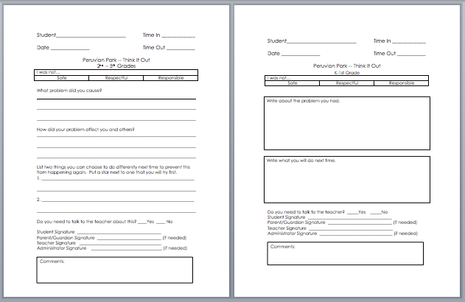

Partner Class
- Occasionally, teachers may determine that an office referral isn’t needed, but that a student does need to be in a partner class for a specific amount of time. In this instance, the teacher is expected to notify the principal. Parents must be notified.
- If a student needs an alternative setting, a partner class must be used. Students are not to be left outside of their classroom unattended. Students found unsupervised outside of their classroom will be sent back into class.
- Think Time and Partner Class Time are two different things with two different purposes. Utilize both for their intended purposes.
  - Think Time is a behavior strategy that allows the student to calm down and come back to class when ready to participate
  - Partner Class Time is a consequence with a set amount of time determined by the adults.

Office Discipline Referrals
ODRs are for repeated Minors and Majors. Prior parent contact will be documented for repeated minors.
Minor
Teacher Managed
- Disruption without harm
- Neglecting to meet expectations – hall, class, bathroom, lunchroom, etc.
- Minor Playground Misbehavior—pushing, rough-housing, name calling (Duty Aide first, Think Wall)
- Student Conflict
- Tattling
- Inappropriate language
- Misuse of Property
- Lying, Cheating
- Taking small items
- Not doing work or completing assignments
- Noncompliance (minor)
- Student scuffles without injury
- Bullying (initial)
- Disrespect
- Inappropriate Physical Contact
Major
Office Managed
- Fighting – Actions involving serious physical contact where injury might occur
- Behaviors causing injury
- Repeated minor offenses in short duration after following protocol
- Repeated bullying
- Safety of children or adults
- Weapons
- Student leaves room or campus without permission
- Violence
- Threats to harm self or others
- Sexual Harassment
- Destruction of Property/Vandalism
- Arson, Theft
- Drugs/Alcohol/Tobacco
- Profane/Obscene language or conduct
- Defiance
- Safe Schools Violations

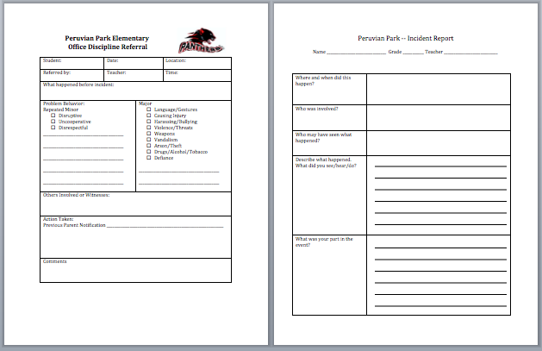

Support Referrals
Teacher Managed
- Classroom Management
- Student Behavior Plans
- Implementing Behavior Plans and Interventions
- Communication with Parents about behaviors
- Management of Individual Students
- Classroom positive rewards
Counselor/Psychologist Managed
- Parenting Help
- Ideas for management plans and interventions when requested by teacher
- Social Groups
- Behavioral Analysis
- Possible Abuse
- Individual Social Skills
- Maintenance
- Classroom presentations
- Character Building
- Emotional Emergencies (by request)
- Contact other agencies or resources
- Significant Behavioral Changes in Student
- Threat to harm self or others

Student disclosures about suicide must immediately be reported to administration and parents. Telling only the school psychologist is not sufficient. Parents of the victims of bullying should also be notified and notification documented. Administration should be notified of student disclosure of neglect or abuse. Mandatory reporting requires you to also notify proper authorities. Keep documentation of all notifications.

