Name:______________________  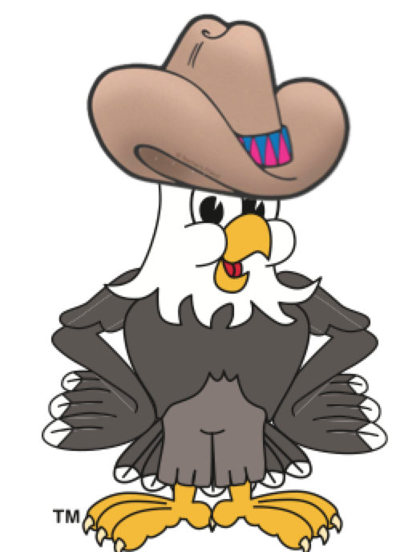  Eagle Eye TRY  Safe Respectful Responsible  Spotted by: | Name:______________________  Eagle Eye TRY  Safe Respectful Responsible  Spotted by: | Name:______________________  Eagle Eye TRY  Safe Respectful Responsible  Spotted by:
Name:______________________  Eagle Eye TRY  Safe Respectful Responsible  Spotted by: | Name:______________________  Eagle Eye TRY  Safe Respectful Responsible  Spotted by: | Name:______________________  Eagle Eye TRY  Safe Respectful Responsible  Spotted by:
Name:______________________  Eagle Eye TRY  Safe Respectful Responsible  Spotted by: | Name:______________________  Eagle Eye TRY  Safe Respectful Responsible  Spotted by: | Name:______________________  Eagle Eye TRY  Safe Respectful Responsible  Spotted by:
Name:______________________  Eagle Eye TRY  Safe Respectful Responsible  Spotted by: | Name:______________________  Eagle Eye TRY  Safe Respectful Responsible  Spotted by: | Name:______________________  Eagle Eye TRY  Safe Respectful Responsible  Spotted by:
Name:______________________  Eagle Eye TRY  Safe Respectful Responsible  Spotted by: | Name:______________________  Eagle Eye TRY  Safe Respectful Responsible  Spotted by: | Name:______________________  Eagle Eye TRY  Safe Respectful Responsible  Spotted by:

