Butler Elementary PBIS Rewards System

Butler Bobcats RESPECT:

People

Places

Things

RESPECT- I give it to you, you give it to me!

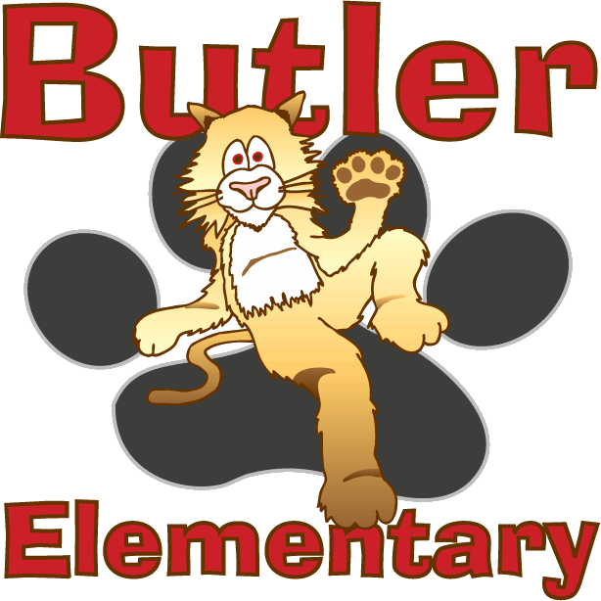

Respect posters are hanging in each classroom throughout the school, as well as hallways, library, computer labs, cafeteria, bathrooms, etc. To reinforce the RESPECT program:
- Teachers and staff members have been given RESPECT tickets to give to students that they see following the PBIS protocols. Students then take these tickets to the office to put into the RESPECT box. Once a month, the principal pulls slips from the RESPECT box for students to receive a prize.
- Once a month, teachers choose 2 students that they feel emulate the RESPECT focus for that month. Students are called to the principal’s office to receive at RESPECT prize.

Name: ____________________________________________
First and Last Name

School Staff

I showed RESPECT to:

 □ People □ Places □ Things

Respect, I give it to you, you give it to me!

